COUNTRIES - PARTICIPANTS
NORWAY 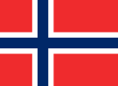 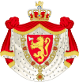
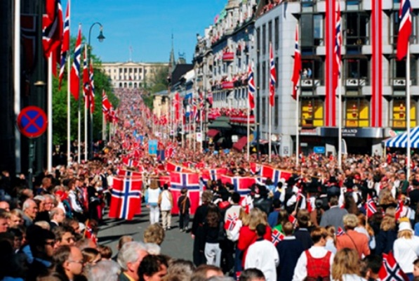
The Kingdom of Norway – is a state in northern Europe, whose territory comprises the western portion of the Scandinavian Peninsula, Jan Mayen and the Arctic archipelago of Svalbard. The country's name means "the northward route" (the "way north" or the "north way").
The capital of Norway is Oslo. Norway has a total area of 385 186 square kilometers. The country shares a long eastern border with Sweden. Norway is bordered by Finland and Russia to the north-east, and the Skagerrak Strait to the south, with Denmark on the other side. Norway has an extensive coastline, facing the North Atlantic Ocean and the Barents Sea.
The population of the country is about 5 million people. More than 90% of the population is Norwegians. The largest national minority are Arabs - several hundred thousand people.
Also in Norway there is another indigenous people - the Sami (about 40 thousand people - 0.8 %).
The capital of the Norwegian Sami is Karasjok. There are about 3 million inhabitants. Important elements of the Sami culture are the Sami language (different from Norwegian) and joik - a traditional Sami chant.
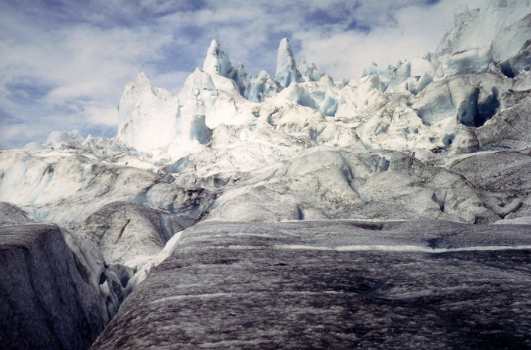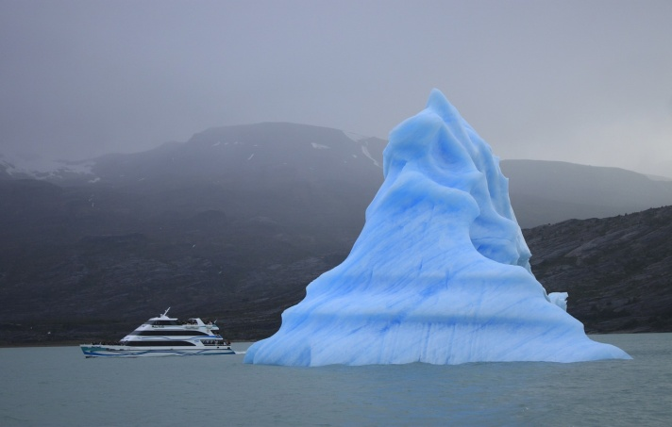

The official language of Norway is Norwegian. In some communes Sami language has equal status with it. After 1989, the community of Norwegian, and Russian Saami have established communication with each other, within which there were arranged Sami Language courses that allowed Sami from Russia to further study in Sami schools in Norway. Classic Norwegian folk art is rosemaling - a unique style of decorative painting on wood that uses stylized flower ornamentation, scrollwork, lining and geometric elements, often in flowing patterns.Wood carving is developed in rural Norway.
Norwegian cuisine is original because of the severe nature and inaccessibility. Cooks are widely use various groats. Traditional Norwegian consists of cereals such as semolina, oat, barley. The basis of the Norwegian cuisine is fish and other sea foods.

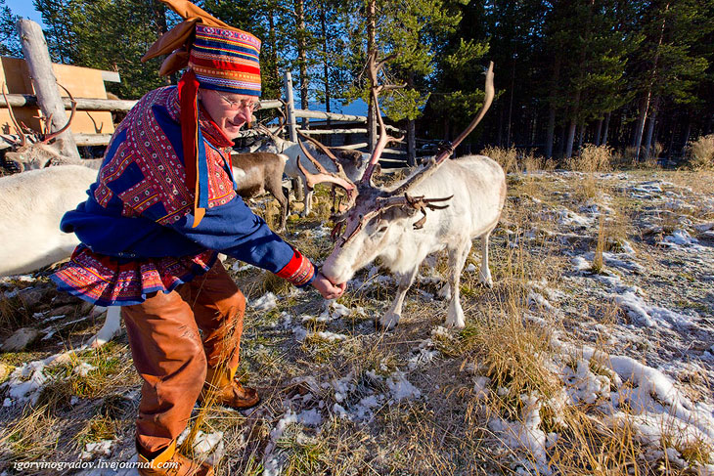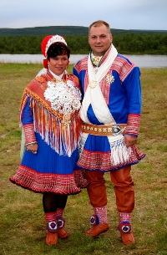
The Halling is a folk dance traditionally performed in rural Norway. This dance is traditionally performed by men at weddings and other celebrations. The musical accompaniment to the dance is usually played on the Norwegian violin - hardingfele."Hallingkast", in this movement, the woman usually holds hat, using a stick, and the dancer should bring down the hat on the floor using his legs. What is remarkable that the hat is usually situated on about 230 - 280 cm above the floor.
Sami celebrate their national holiday annually on February 6. On this day in 1917 the first meeting of the Sami took place.
